**MY SQL ASSIGNMENT 4**

(Sanchay Shukla)

CREATE DATABASE IF NOT EXISTS SalesDB;

USE SalesDB;

CREATE TABLE Sales (

SaleID INT PRIMARY KEY,

ProductID INT,

CustomerID INT,

SaleDate DATE,

Quantity INT,

UnitPrice DECIMAL(10, 2),

Region VARCHAR(50)

);

INSERT INTO Sales (SaleID, ProductID, CustomerID, SaleDate, Quantity, UnitPrice, Region) VALUES

(1, 101, 1001, '2024-01-05', 5, 200, 'North'),

(2, 102, 1002, '2024-01-10', 10, 150, 'East'),

(3, 103, 1003, '2024-02-15', 2, 300, 'North'),

(4, 104, 1001, '2024-02-20', 7, 250, 'West'),

(5, 101, 1004, '2024-03-05', 1, 200, 'East');

**select * from Sales;**

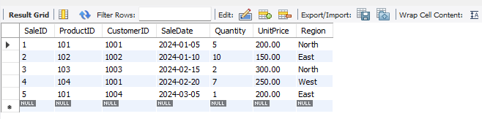

**-- 1. Calculate the total sales (Quantity * UnitPrice) for each product**

SELECT ProductID, SUM(Quantity * UnitPrice) AS TotalSales

FROM Sales

GROUP BY ProductID;

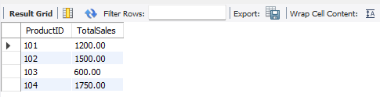

**-- 2. Find the total number of products sold in each region**

SELECT Region, SUM(Quantity) AS TotalProductsSold

FROM Sales

GROUP BY Region;

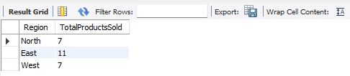

**-- 3. Get the average sales amount per product**

SELECT ProductID, AVG(Quantity * UnitPrice) AS AverageSales

FROM Sales

GROUP BY ProductID;

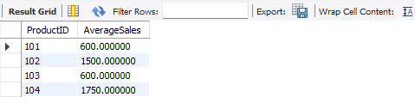

**-- 4. Find the regions where total sales are more than 3000**

SELECT Region

FROM Sales

GROUP BY Region

HAVING SUM(Quantity * UnitPrice) > 3000;

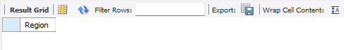

**-- 5. Get the maximum quantity sold for each product**

SELECT ProductID, MAX(Quantity) AS MaxQuantitySold

FROM Sales

GROUP BY ProductID;

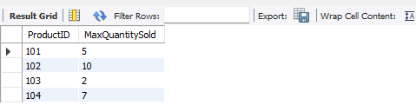

**-- 6. Calculate the average quantity of products sold per region**

SELECT Region, AVG(Quantity) AS AverageQuantitySold

FROM Sales

GROUP BY Region;

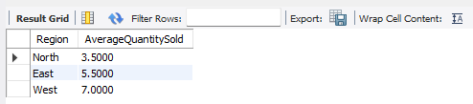

**-- 7. Find the product IDs that have generated a total sales amount of more than 1000**

SELECT ProductID

FROM Sales

GROUP BY ProductID

HAVING SUM(Quantity * UnitPrice) > 1000;

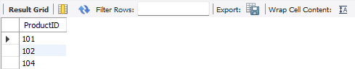

**-- 8. Get the total number of sales (rows) made for each customer**

SELECT CustomerID, COUNT(*) AS TotalSales

FROM Sales

GROUP BY CustomerID;

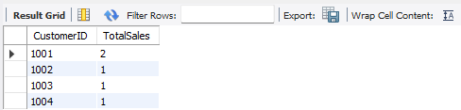

**-- 9. Find the products for which the average quantity sold is less than 5**

SELECT ProductID

FROM Sales

GROUP BY ProductID

HAVING AVG(Quantity) < 5;

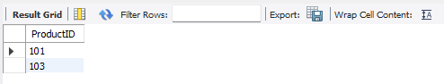

**-- 10. Find the sum of total sales for each customer in each region**

SELECT CustomerID, Region, SUM(Quantity * UnitPrice) AS TotalSales

FROM Sales

GROUP BY CustomerID, Region;

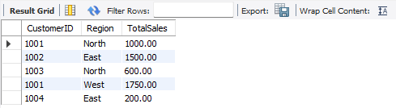

**-- 11. Calculate the total sales for each month**

SELECT DATE_FORMAT(SaleDate, '%Y-%m') AS SaleMonth, SUM(Quantity * UnitPrice) AS TotalSales

FROM Sales

GROUP BY SaleMonth;

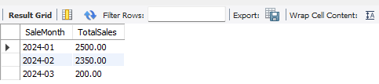

**-- 12. Find the regions where the average unit price is more than 200**

SELECT Region

FROM Sales

GROUP BY Region

HAVING AVG(UnitPrice) > 200;

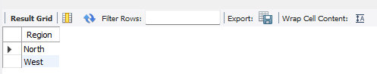

**-- 13. Get the minimum and maximum quantity sold per region**

SELECT Region, MIN(Quantity) AS MinQuantitySold, MAX(Quantity) AS MaxQuantitySold

FROM Sales

GROUP BY Region;

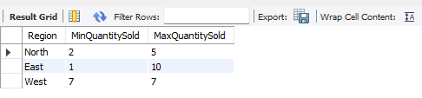

**-- 14. Find the customers who have made more than 2 purchases**

SELECT CustomerID

FROM Sales

GROUP BY CustomerID

HAVING COUNT(*) > 2;

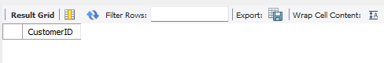

**-- 15. Find the total sales for each product and filter only those products where the total sales exceed 1500**

SELECT ProductID, SUM(Quantity * UnitPrice) AS TotalSales

FROM Sales

GROUP BY ProductID

HAVING TotalSales > 1500;

